Weekly Letter
English I
Week 3
August 29-September 2

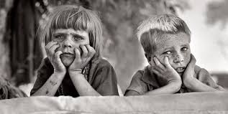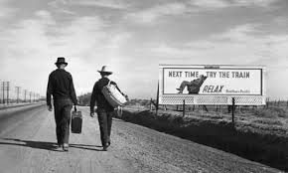
Like most writers, Steinbeck uses this novella as a mouthpiece for social commentary during this time period. You will quickly recognize themes, setting, stylistic choices (figurative language), and the realistic POV from this author. As a result, we will be able to analyze the lasting impact Steinbeck has on our American culture. Be aware that many social issues we be imbedded in this example of fiction. That is what makes this novella a classic in literature.

So where are some examples of Naturalism?
Why would this be called Realism?
Why is realism an acceptable form of writing during the 1850-early 1900s
--------------------------------------------------------------------------------------------------------------------------------------------

Learning Goals:
CCSS:
- I can Initiate and participate effectively in a range of collaborative discussions (one-on-one, in groups, and teacher-led) with diverse partners on grades 11–12 topics, texts, and issues, building on others’ ideas and expressing their own clearly and persuasively.
c. Propel conversations by posing and responding to questions that probe reasoning and evidence; ensure a hearing for a full range of positions on a topic or issue; clarify, verify, or challenge ideas and conclusions; and promote divergent and creative perspectives.
d. Respond thoughtfully to diverse perspectives; synthesize comments, claims, and evidence made on all sides of an issue; resolve contradictions when possible; and determine what additional information or research is required to deepen the investigation or complete the task.
- I can cite strong and thorough textual evidence to support analysis of what the text says explicitly as well as inferences drawn from the text, including determining where the text leaves matters uncertain.
- I can determine the meaning of words and phrases as they are used in the text, including figurative and connotative meanings; analyze the cumulative impact of specific word choices on meaning and tone (e.g., how the language evokes a sense of time and place; how it sets a formal or informal tone).
- I can read closely and find answers explicitly in text and answers that require an inference
- I can thoroughly support both explicit and inferential questions by analyzing an author’s words and determining multiple pieces of textual evidence that strongly support those questions.
- I can determine how specific details in the text reveal and continually refine a theme.
- I can analyze how complex characters develop over the course of the grade-appropriate text, interact with other characters, and advance the plot of a text or develop the theme.
- I can analyze how specific word choices build upon one another to create a cumulative impact on the overall meaning and tone of a text (i.e., denotative, connotative, figurative)
- I can determine a central idea of a text and analyze its development over the course of the text, including how it emerges and is shaped and refined by specific details; provide an objective summary of the text.
- I can analyze the context of various texts and determine how language choice affects meaning, style, and comprehension.
- I can determine an author’s point of view and explain his/her purpose for writing the text.(Realism/Naturalism)
- I can identify and analyze various accounts of the same subject and determine which details are emphasized in each medium.

--------------------------------------------------------------------------------------------------------------------------------
M: Weekly letter---Independent Reading
Finish Steinbeck PowerPoint: take notes
Define Naturalism and realism—why is this appropriate to the writing style for Steinbeck?
Begin chapter 1
Hmwk: Please be read through chapter 1 and complete Whams and Slams through chapter 1, finish the questions for chapter 1 study guide, and a few examples of Naturalism from the text.

T: Picture Day----Report to classroom and we will go down to take pictures as a class. Smile Pretty!
SG, Whams and Slams, and examples of Naturalism discussed.
LAB 217:
Hmwk: Research how America suffered in the early 1900’s and today. Bring in 2 articles that support this suffering. Write down 10 adjectives that describe the plight of the Great Depression and the suffering of today.

W: Discuss the importance of imagery in chapter 1. What can we do with the onion?
PowerPoint on setting
Worksheet for setting definition and analysis
HWK: Finish reading chapter 2; complete vocabulary for chapter 2, Whams & Slams, and SG

TH Setting formative (3 questions)
Discussion about literary elements of setting and metaphors
Discuss examples from 7th most important thing/OMAM
Complete discussion questions in small groups---
Write a summary of the small group discussion
Written analysis turned in at the end of class
HMWK: Read chapter 3, SG, Whams, and Slams

F Reading quiz on chapters 1&2 with 2 setting questions
Discuss chapter 3 with setting, metaphors, whams, slams, and realism
HMWK: Read chapter 4, SG, Whams and Slams, examples of setting, naturalism, characterization

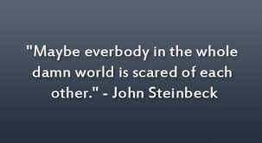

**Looking Ahead-Of Mice and Men symbolism, characterization, diction, themes, and naturalism. Summative Test –Around 9/15!**

